***Team Details and College Logo***

***SOFTWARE PROJECT PLAN***

***FOR REQUEST US & MAPS***

**1.0 Introduction**

This project is to implement to do a web application enhancements called **Request Us** Page for requesting of required items likes tables,books,computers….. to gain best education for less budget schools or free schools for the existing application name called “**chatrasahaya**”.So that end users can submit the needs of required items whenever required for the schools.

* 1. **Project scope**

Users can submit their required needs such as books , tables etc…from the **Request Us** Page by using some fields such as **Name** -- Full Name of the requester , **Phone Number** -- Phone/mobile Number of the Requester , **Location** -- The place of the request where books,chairs,tables are needed for the schools , **Description** -- Its was the description/overview of the need , **Documents** --- Proof of the documents needs to be uploaded here.

**Count in Maps :** Our Team can view the number of the places count where services are provided by state level in the Map indication

* 1. **Major software function**
* Request Us Form --- Submitting of the Request of needs for the schools
* Mail Notification ---Sending of the Mail Notifications for the Request to our team
* Map View -- To show the counts by the state level in the Map
* Count View --- To view the details for the each service provided with the images
  1. **Performance/Behavior issues**

We may face some performance/behavioral issues like when more users are requesting the items at a time , and loading issues when user try to upload the large size files in the Documents section and its take time to submit the form with large size of files.

* 1. **Management and technical constraints**

We will deliver the all the required enhancements and projects requirements in the time

**2.0 Risk Management**

This section discusses project risks and the approach to managing them.

**2.1 Project Risks**

Project risks are events or circumstances that can potentially have a negative impact on a project's objectives, such as its scope, schedule, budget, or quality. Identifying and assessing project risks is a crucial part of project management.

* Scope Creep
* Resource Constraints
* Schedule Delays
* Quality Issues
* Technical Challenges
* Communication Breakdown

**2.2 Risk Table**

|  |  |  |  |
| --- | --- | --- | --- |
| **Name of risk** | **probability** | **impact** | **RM3 pointer** |
| Scope Creep | less | Impact on Design of the requirement | Initial |
| Resource Constraints | less | Impact on Schedule Timings | Optimized |
| Schedule Delays | medium | Impact on Timely Deliverable | Defined |
| Quality Issues | medium | Impact on Output of the requirement | Optimized |
| Technical Challenges | medium | Impact on Proper Coding & testing | Initial |
| Communication Breakdown | medium | Impact on Design of the requirement | Initial |

**2.3 Overview of Risk Mitigation, Monitoring, Management (RM3)**

 RM3 Pointer indicates the level of maturity in risk management for each risk. It can be one of the three RM3 levels: Initial, Defined, or Optimized.

"Initial" suggests that the organization is in the early stages of risk management.

"Defined" implies that the organization has established processes and practices for risk management but may not have fully optimized them.

"Optimized" indicates that the organization has advanced risk management practices in place and continuously improves them.

**3.0 Project Schedule**

**3.1 Project task set**

We are going to implement our application using the tools like:

* Microsoft Visual Studio
* WordPress PHP on Go-daddy itself
* Microsoft SQL Server Management Studio

We are planning to implement the website using Python, MySQL,JavaScript,

HTML, CSS and as well testing of the website can be followed in time

**3.2 Functional decomposition**

Functional Decomposition includes

* **Requirement Analysis** -- As the requirement with the team and started working on it , in analysis stage , we have cleared our doubts to develop the maps counts and request us form
* **Design** -- We prepare the design or specification document for the requirement and which can submitted by the time line
* **Development** -- 1. Front-end development---HTML/CSS coding ,Python, 2. Back-end development--- Database implementation
* **Testing** -- Unit testing , Functional testing and test cases , Regression testing and Retesting for issues , final testing of the requirement

**3.3 Task network**

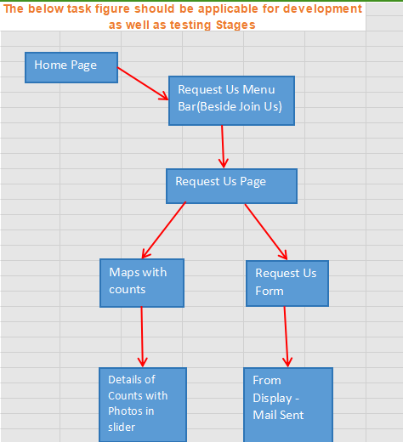

**3.4 Timeline chart**

* Project Plan – 09/21/2023
* Software Requirement Specification (SRS) – 10/05/2023
* Software Design Specification (SDS) – 10/19/2023
* Initial version of software – 11/02/2023
* Test plan – 11/09/2023
* Project Deliverables – 12/07/2023
* Project presentation and demonstration(Final Project) --12/5/2023-12/7/2023

**3.5 Schedule compliance**

We will Monitor and schedule the timeline and finish the project in time